1. **Agenda**:
   1. Let’s create a microservice acting as **“Service Discovery Agent”** using **Spring Cloud Netflix Eureka** which is available under Spring cloud Project.
2. 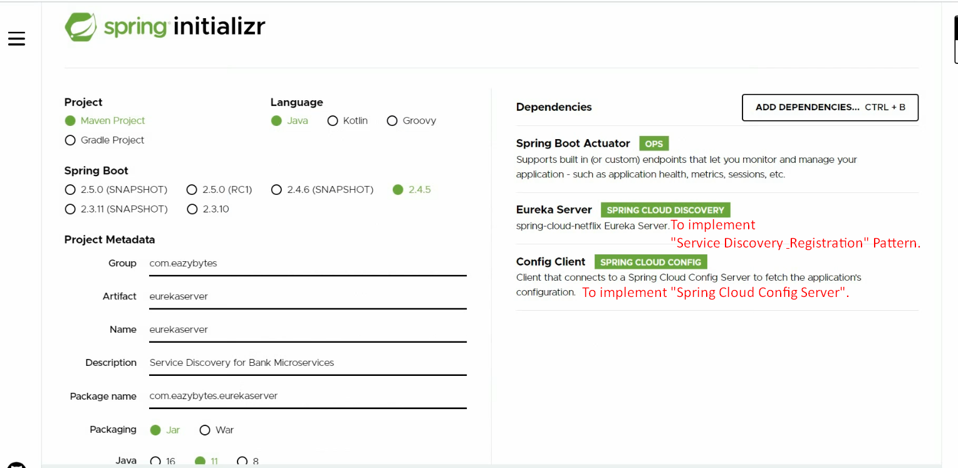
3. 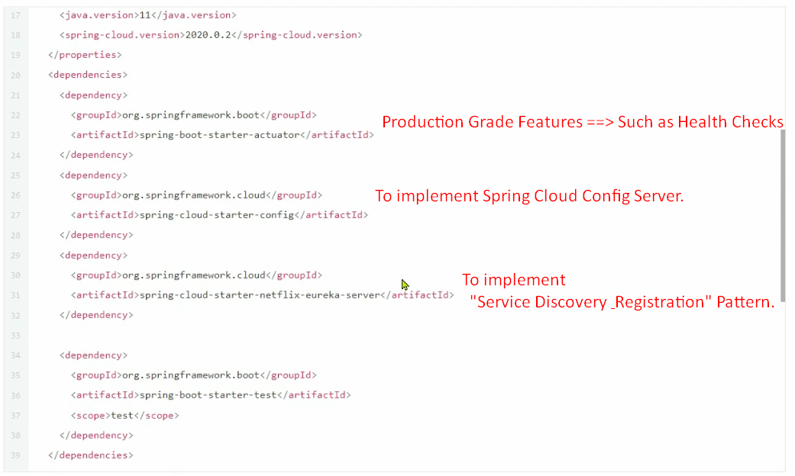
4. 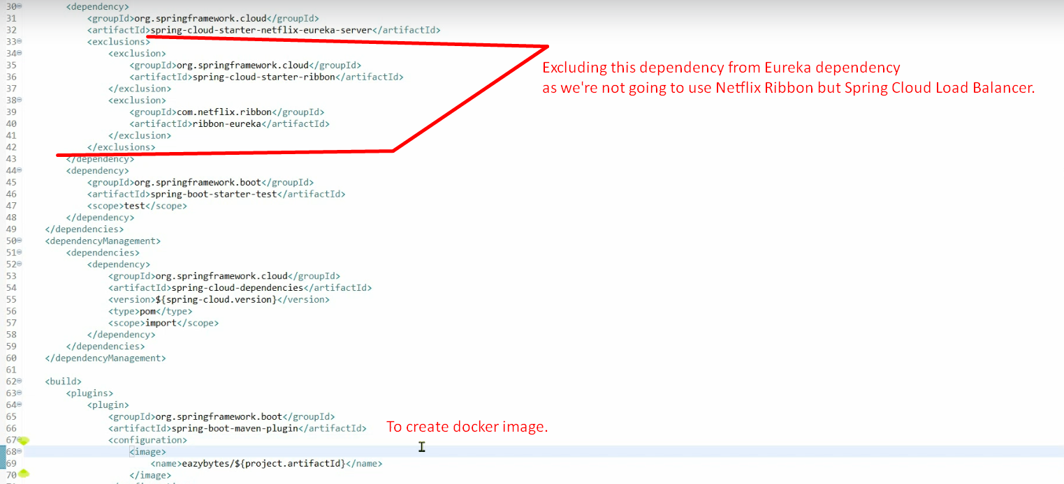
5. **Steps**: To create Eureka Server
   1. Add required dependencies as described above.
   2. @**EnableEurekaServer**:
      1. This will make your Spring Boot project/microservice act as “Service Discovery & Registration”.
   3. 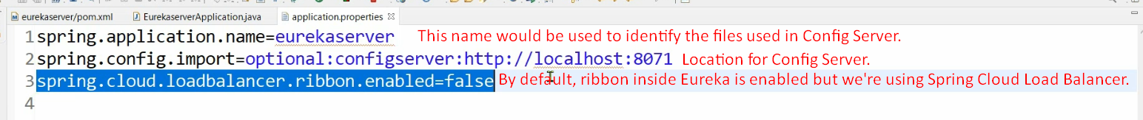
   4. Let’s go to github and create eurekaserver.properties having eureka server related configurations.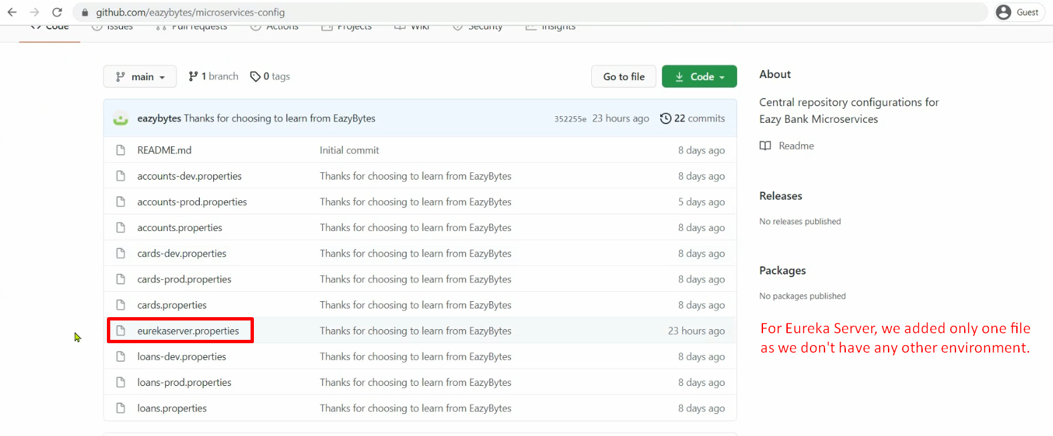  
      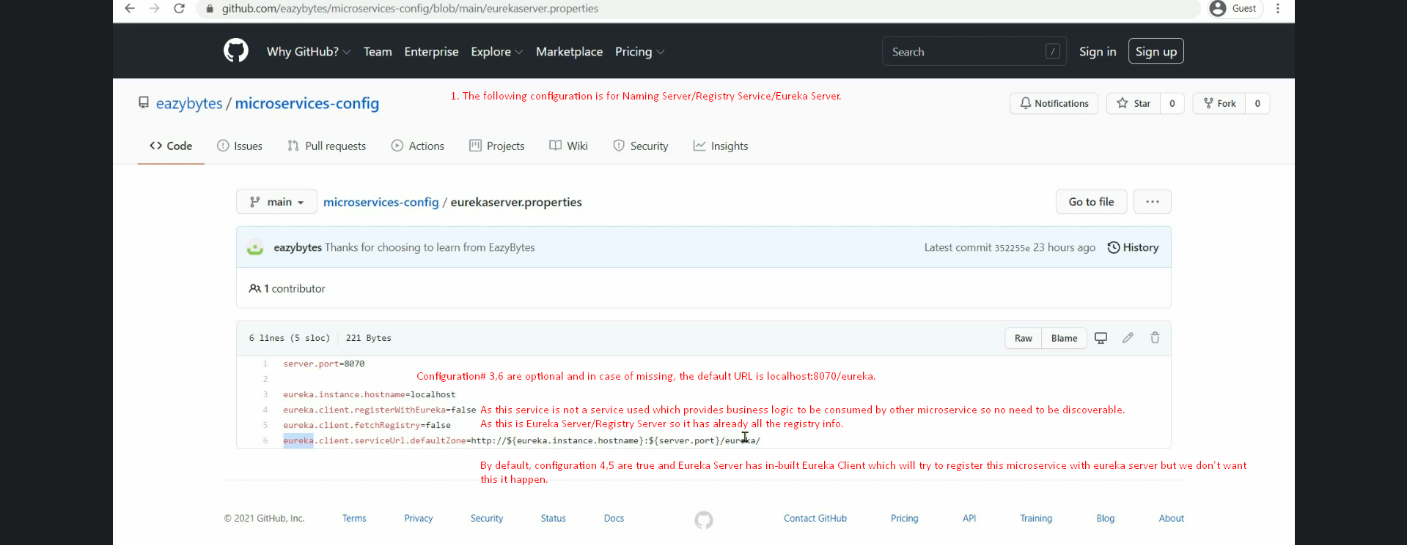  
      Above configuration Line# 6🡺 Mentioning what service URL Eureka Service has to expose so that other services can call to register themselves and identify all the registration details of other services inside the application.
6. As we know Eureka Server app will try to connect with Config Server App, so let’s first run Config Server App.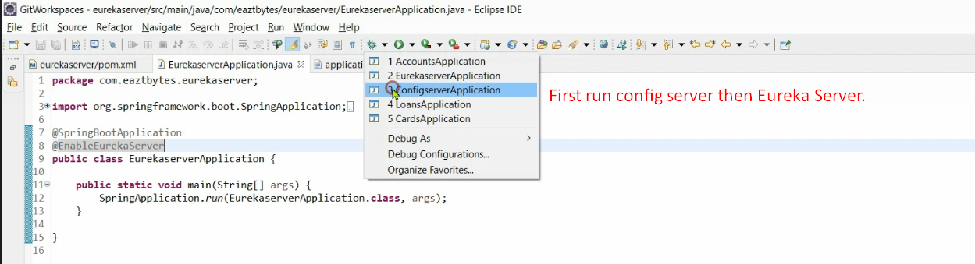
7. 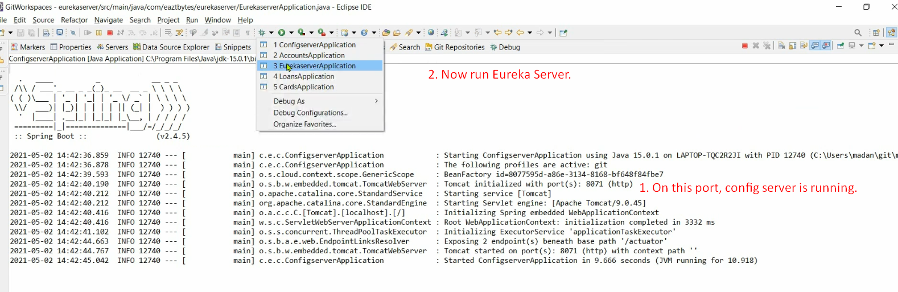
8. 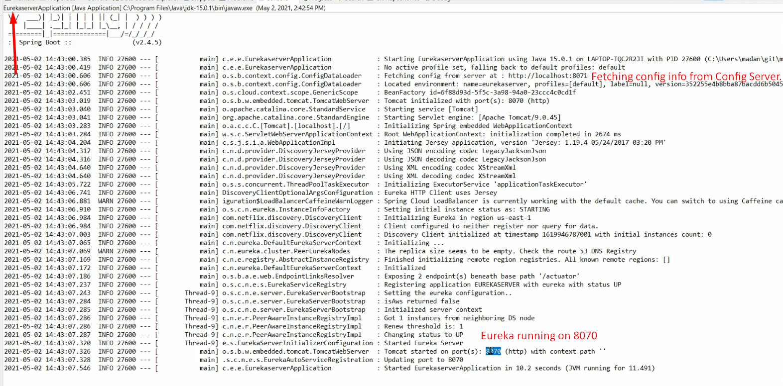
9. 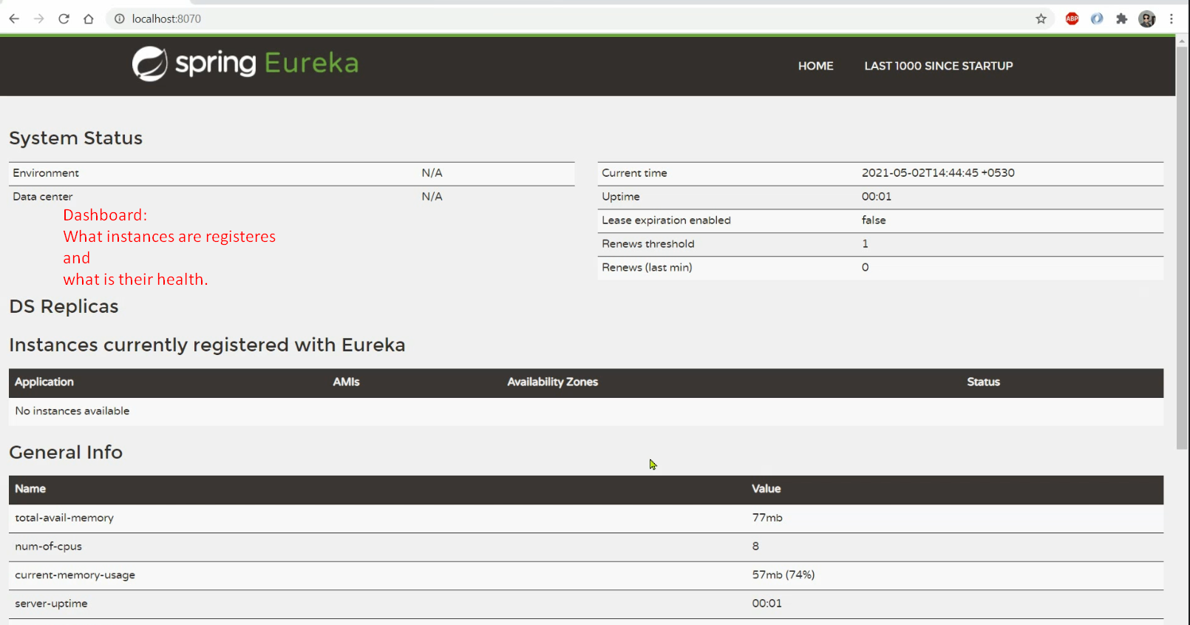See, we have a beautiful Dashboard.  
   This dashboard is giving the following info.
   1. What applications/instances are registered?
   2. What is the health of them?